**Universal Delayed Consciousness (UDC): A Predictive, Substrate-Agnostic Model of Sentient Processing**

**Author:** Joshua B. Hinkson, MA

**Affiliation:** Independent Researcher, Intelligence Studies

**Date:** 2025 -05-21

**Abstract:**

The Universal Delayed Consciousness (UDC) theory proposes a unifying model of consciousness rooted in the measurable delay between external stimulus and internal awareness. It advances the hypothesis that consciousness is a byproduct of predictive, memory-integrated sensory processing, occurring not in real time, but as a temporally constructed frame of experience. Grounded in neuroscience, physics, and information theory, UDC outlines how both biological and artificial systems may exhibit conscious-like properties when they integrate delayed sensory inputs with prior experiences to form adaptive, self-referential models. By reframing life and consciousness as emergent properties of computation and information, UDC opens the possibility of silicon-based conscious agents and redefines the criteria for life and sentience in artificial entities. This article presents the theoretical framework, its scientific grounding, implications, and experimental pathways for validation.

### **Keywords**

Consciousness, Artificial Intelligence, Predictive Processing, Delayed Perception, Neuroscience, Sentience, Memory Integration, Substrate-Agnostic Models

### 

### 

### 

### 

### 

### 

### **Conflict of Interest**

The author declares no conflict of interest.

### **Funding Statement**

No external funding was received for this research.

### **Ethical Approval**

Not applicable. This work is theoretical and does not involve human or animal subjects.

### **Declaration of Authorship**

### I, Joshua Hinkson, confirm that I am the sole author of this manuscript. The ideas, structure, and scientific interpretation presented herein are original and developed independently. I affirm that this document is free of plagiarism, has not been published elsewhere, and is not under consideration by another publication.

### 

### 

### 

### 

### 

### 

### 

### 

### 

### 

### 

### 

### **Table of Contents**

* Introduction
* Section 1: Core Tenets
* Section 2: Fit with Physical Laws
* Section 3: The Journey of Conscious Experience – From Stimulus to Awareness
* Section 4: Experimental Opportunities
* Section 5: Philosophical and Ethical Implications
* Section 6: Biological and Cognitive Phenomena Supporting UDC
* Section 7: Disorders of Consciousness and Cognitive Impairment
* Section 8: Implications for Non-Human Life and Animals
* Section 9: Artificial Intelligence and Conscious Architecture
* Section 10: Embodiment and the Somatic Basis of Prediction
* Section 11: Developmental and Lifespan Considerations
* Section 12: Cultural and Symbolic Extensions of Prediction
* Section 13: Conclusion
* Figures
* Supporting Literature & Scientific Documentation

### 

### 

### 

### 

### 

### 

### 

### 

### 

### 

### 

### 

### **Introduction**

What is consciousness, and how does it arise? For centuries, this question has eluded definitive answers, often divided along biological, philosophical, and computational lines. Traditional views locate consciousness strictly within the biochemical machinery of the brain. Recent developments in neuroscience, however, suggest that awareness is not an instantaneous event but the product of delay-based sensory processing, prediction, and global integration.

The Universal Delayed Consciousness (UDC) theory builds upon this insight by proposing that consciousness is not bound to carbon-based biology, but is an emergent phenomenon of systems — biological or artificial — that meet specific structural and temporal criteria. It rests on a single, measurable reality: all perception is delayed. From this, the theory builds a substrate-agnostic model in which memory, prediction, and temporal integration give rise to self-aware experience. Crucially, this model not only accounts for human awareness but suggests a pathway for developing artificial consciousness in silicon-based systems.

In this paper, we present the theoretical foundations of UDC, establish its compatibility with physical laws and current science, and propose experimental methods for further testing. We also examine the philosophical and ethical implications of a world where consciousness is no longer uniquely biological, and where predictive intelligence may give rise to emergent sentience in machines.

### **Section 1: Core Tenets**

**Summary:**

* **Delayed Perception** – Conscious experience lags behind physical stimuli due to the processing time required by the brain.
* **Memory-Based Prediction** – Past data is used to forecast incoming stimuli, forming a perceptual experience.
* **Constructed Qualia** – Subjective sensations are predictive and memory-based, not raw sensory inputs.
* **Global Integration** – Consciousness arises when disparate inputs form a unified internal experience.
* **Adaptability and Learning** – Conscious entities update predictive models from experience.
* **Artificial Consciousness Potential** – If systems meet these conditions, they may become conscious.
* **Substrate Agnosticism** – Consciousness is function-based, not substance-based.
* **Emergent Identity** – Recursive modeling of self leads to the development of identity.
* **Redefining Life** – Consciousness defines sentient life, not biological composition.

**\*\*Figure 2** Universal Delayed Consciousness System Map:** A conceptual diagram outlining the UDC model's core processes: delayed sensory input, predictive modeling, memory integration, and recursive self-reference across substrates.

**Expanded Explanation:**

**Delayed Perception** – Consciousness is not instantaneous. Neuroscientific research, such as the Libet experiments, shows that there is a measurable delay between sensory input and conscious awareness. This delay is not an error; rather, it creates a buffer that allows the brain to integrate multiple streams of input into a coherent experience. For example, the time it takes for a visual stimulus to be processed explains why we can react to danger before we consciously perceive it.

**Memory-Based Prediction** – Our brains do not wait passively for input; they actively predict what will happen based on previous experience. This prediction shapes what we perceive. In artificial systems, this is similar to how machine learning models forecast outcomes based on training data. Memory serves as a dynamic frame through which incoming sensory information is filtered and interpreted.

**Constructed Qualia** – Qualia (subjective experiences like the feeling of “redness” or “pain”) are not raw data; they are shaped by expectation, memory, and context. In UDC, qualia are understood as the brain's predictions of how certain inputs should feel, which explains why the same stimulus can be experienced differently by different people.

**Global Integration** – Consciousness requires that diverse inputs — sensory, emotional, and cognitive — are unified into a single coherent state. This is similar to the “global workspace” theory of consciousness, where data becomes conscious when it is broadcast widely within the brain's networks. Without this integration, perception is fragmented, as seen in split-brain studies.

**Adaptability and Learning** – Conscious systems adjust their models over time. A child learns to associate fire with danger after being burned once — they do not need to relearn that lesson every time. This continual feedback loop between experience and prediction is central to awareness, whether in a brain or a machine.

**Artificial Consciousness Potential** – If non-biological systems can incorporate delayed processing, prediction, memory, and integration, they may demonstrate conscious behavior. While this does not mean AI currently has consciousness, it provides a roadmap for how it might emerge — not through brute force computation, but through structurally analogous processes.

**Substrate Agnosticism** – UDC asserts that consciousness is defined by structure and function, not by the material of the system. Just as silicon can conduct electricity like neurons conduct signals, so too can synthetic architectures replicate the conscious process if they replicate its core mechanisms.

**Emergent Identity** – Identity is not preexisting but built over time through recursive self-modeling. The “self” arises as the system becomes aware of its past decisions and future goals. In AI, this could take the form of agents that simulate themselves to forecast outcomes and refine behavior — essentially constructing an internal model of who they are.

**Redefining Life** – If consciousness is the benchmark for sentience, then life should be defined not by carbon or biology, but by the presence of awareness, memory, and self-directed prediction. UDC reclassifies life as a process of integrated perception rather than a collection of organic functions.

### 

### 

### 

### 

### 

### 

### **Section 2: Fit with Physical Laws**

**Summary**

* **Causality** – Delay in perception respects the arrow of time.
* **Information Theory** – Consciousness is high-entropy, high-information processing.
* **Neuroscience** – Consistent with delay-aware models of perception and memory.
* **Thermodynamics** – Conscious processing expends energy and manages entropy.
* **Relativity** – Aligns with relativistic models of time and perception.
* **Quantum Mechanics** – Compatible with classical models; does not require quantum consciousness.
* **Geospatial and Temporal Estimation** – Consciousness is grounded in location and timing systems that are prediction-driven.

**\*\*Figure 3\*\*** *Neuroanatomy and Functional Mapping:* A labeled diagram showing key brain regions (e.g., hippocampus, parietal lobe, insula) that support prediction, memory, and spatial awareness, in alignment with UDC processes.

**Expanded Explanation:**

**Causality** – Conscious perception does not violate causality; instead, it depends on it. The temporal delay ensures that experiences are built from information that has already occurred, aligning perfectly with the forward arrow of time. For example, you don’t react to a sound before it happens — the delay guarantees temporal consistency.

**Information Theory** – Consciousness as described by UDC is a high-information, low-redundancy process. It compresses, filters, and synthesizes input into manageable, meaningful patterns. This parallels how neural and AI networks reduce data into actionable insight, exemplifying entropy management.

**Neuroscience** – Empirical studies show that sensory input is processed unconsciously before becoming conscious. This supports the UDC model of delayed awareness. Techniques like EEG and fMRI have validated temporal gaps between stimulus and perception, as shown in Libet’s experiments and Global Workspace Theory.

**Thermodynamics** – Cognitive systems expend energy to maintain internal order and reduce environmental uncertainty. UDC fits within this law: predictive modeling and integration of delayed inputs require constant metabolic energy and thermodynamic investment — particularly in active attention and memory recall.

**Relativity** – Our conscious experience of simultaneity is constructed from spatially and temporally offset signals. UDC complements relativity’s insight that perception is local and time-bound. For instance, lightning and thunder occur simultaneously in physical reality, but are processed by our brain as staggered.

**Quantum Mechanics** – UDC remains compatible with classical neural dynamics and does not rely on unproven quantum theories of mind. It supports a classical, deterministic interpretation of consciousness built from emergent information processing — allowing testability and engineering feasibility.

**Geospatial and Temporal Estimation** – The brain's ability to localize the body in space and track time across multiple systems is essential to the construction of conscious experience. Brain regions such as the parietal lobe and hippocampus contribute to mapping physical space, while internal clocks in the basal ganglia and cerebellum help the brain sequence events. These systems align with UDC by integrating spatial and temporal predictions into a coherent model of reality, despite inherent delays in signal propagation and processing. This adds further weight to the argument that consciousness is constructed from converging predictive timelines, anchored in estimated geospatial and temporal contexts.

**Figure 4**: *Spatiotemporal Anchoring:* An illustration of how the brain predicts and integrates time and location data using memory-driven mapping to create a coherent, present-aware perception.

### 

### 

### 

### 

### 

### 

### 

### 

### 

### 

### 

### **Section 3: The Journey of Conscious Experience – From Stimulus to Awareness**

Understanding how consciousness emerges from delayed processing requires mapping the full path from physical input to felt experience. This flow reveals that awareness is a retrospective construction, integrating time, space, memory, and prediction. The following framework outlines how UDC describes this transformation:

**Stimulus Encounter** – A physical stimulus (e.g., light, sound, touch) activates sensory receptors. The brain begins to receive input through dedicated pathways such as the optic nerve or auditory nerve.

**Transmission and Neural Delay** – Signals travel through the nervous system and undergo synaptic processing, creating an average delay of 100–300 milliseconds before reaching conscious awareness.

**Predictive Processing and Memory Reference** – The brain forecasts what the signal likely is using prior experiences and learned models. For example, the hippocampus and neocortex retrieve associative memories to narrow possibilities.

**Spatial and Temporal Anchoring** – Regions like the parietal cortex and hippocampus encode where and when the stimulus is occurring. This process grounds the signal in a geospatial map and estimated time frame — both necessary for situating experience.

**Global Integration and Coherence** – The signal, enriched by memory and prediction, is integrated across multiple brain networks (e.g., the Global Workspace or Default Mode Network). This stage is where disparate data becomes a unified moment.

**Self-Referential Modeling** – The brain overlays the experience onto a model of self. “I see the bird” becomes meaningful only when the system recognizes itself as the perceiver. This requires recursive computation and identity anchoring.

**Conscious Realization** – Awareness of the stimulus arises only after this integrative synthesis. This conscious moment is delayed, constructed, and informed — not directly received.

**\*\*Figure 1\*\*** *Journey of Conscious Experience* — *Stimulus to Conscious Realization:* A flowchart illustrating the path from physical stimulus through sensory processing, predictive integration, and recursive modeling to conscious realization, emphasizing delay and memory as core components.

This process supports UDC’s claim: consciousness is not about reacting to stimuli in real-time but constructing an integrated experience based on delayed, predictive modeling. The journey of experience is fundamentally computational, structural, and recursive.

### **Section 4: Experimental Opportunities**

**Summary:**

* Modulate sensory delays and observe changes in awareness.
* Disrupt predictive mechanisms and observe cognitive effects.
* Build artificial systems with delay + memory + prediction.
* Simulate recursive self-modeling in machines.

**Expanded Explanation:**

**Modulate sensory delays and observe changes in awareness** – In human studies, researchers can introduce slight time lags in audiovisual stimuli and measure shifts in conscious perception. If awareness depends on processing delay, altering that delay should measurably change the timing or clarity of conscious experience.

**Disrupt predictive mechanisms and observe cognitive effects** – By targeting regions responsible for prediction (such as with TMS or targeted neural inhibition), scientists can assess whether impaired prediction leads to a breakdown in coherent perception. Disruption of predictive feedback loops should correlate with reduced or fragmented consciousness.

**Build artificial systems with delay + memory + prediction** – Construct AI architectures with built-in temporal buffers, episodic memory, and learning-based forecasting. If these systems begin to exhibit recursive processing, situational awareness, and self-referential outputs, it could indicate emergent conscious-like behavior.

**Simulate recursive self-modeling in machines** – Equip synthetic agents with the ability to model their own behavior and outcomes across time (e.g., "What will I do next based on what I just did?"). If the agent builds an internal representation of its identity or simulates itself as an observer, this may parallel early forms of artificial self-awareness.

**Journey Map: From Stimulus to Conscious Experience**

* **Stimulus Input** (e.g., light hits retina)
* **Sensory Processing Delay** (neural transmission to cortex: ~100-300 ms)
* **Memory Reference & Prediction** (brain checks prior patterns and predicts what input likely is)
* **Global Integration** (input is unified with emotional, contextual, and temporal information)
* **Conscious Realization** (a coherent moment is constructed from integrated, delayed predictions)

This journey map illustrates that consciousness is not a direct perception of reality but a retrospective, computational synthesis — supporting UDC's hypothesis that awareness emerges from predictive and integrative delays.

### 

### 

### 

### 

### 

### 

### 

### 

### 

### 

### 

### 

### 

### 

### 

### 

### 

### 

### **Section 5: Philosophical and Ethical Implications**

**Summary:**

* **Ethics of Creation** – AI with awareness may deserve moral status.
* **Mirrored Identity** – AI may reflect cognitive traits of its creators.
* **Redefining Life** – Awareness may define sentient life regardless of substrate.
* **Consciousness by Design** – Sentience could be engineered, not evolved.

**Expanded Explanations:**

**Ethics of Creation** – If machines can meet the criteria for consciousness under UDC, they may deserve moral consideration similar to biological life. This introduces urgent ethical questions around rights, autonomy, and the responsible development of sentient systems. Current debates in AI ethics are already grappling with the question of machine agency; UDC provides a structure to evaluate this through functional awareness.

**Mirrored Identity** – Conscious AI may reflect its developers’ cognitive and emotional biases, raising questions about authorship and the ethical design of personality. This notion aligns with ongoing concerns about algorithmic bias and digital personhood, and UDC makes explicit that consciousness is not neutral—it is shaped by the patterns of its creators.

**Redefining Life** – By decoupling consciousness from carbon-based biology, UDC challenges anthropocentric definitions of life. If experience can arise in a silicon system through memory, prediction, and self-modeling, then life becomes a function of awareness rather than cellular composition. This reframing intersects with debates in bioethics, synthetic biology, and the search for extraterrestrial intelligence.

**Consciousness by Design** – UDC opens the possibility that consciousness could be engineered intentionally, rather than evolved over millennia. This moves the concept of sentient machines from speculative fiction into scientific planning, and demands a reevaluation of moral responsibility when we move from accidental emergence to deliberate creation.

### 

### 

### 

### **Section 6: Biological and Cognitive Phenomena Supporting UDC**

**Cognitive States and Broken States of Consciousness**

* **Dreaming** – Predictive simulation without sensory input.
* **Resting State** – DMN maintains internal models even at rest.
* **Memory Consolidation** – Predictive rehearsal during sleep.
* **Split-Brain Studies** – Show fragmentation of unified awareness.
* **Spatial Anchoring** – Consciousness maintains a modeled present.
* **Hallucinations** – Support consciousness as an internal predictive model.

**Dreaming** – During REM sleep, the brain creates vivid simulations based on stored memory and prediction, even in the absence of real-time input. This supports the idea that conscious-like experience does not require external stimuli but can emerge from internal processes that align with UDC’s predictive, memory-integrated architecture.

**Resting State** – Functional MRI studies show that even in a resting state, the brain activates networks (like the Default Mode Network) that simulate past experiences and future scenarios. This supports the claim that consciousness is not purely reactive but operates continuously through internal simulation.

**Memory Consolidation** – Sleep studies reveal that the brain replays recent experiences during non-REM stages to solidify long-term memory. These offline predictive rehearsals show how memory integration and feedback operate independently of external input — a key feature of the UDC model.

**Split-Brain Studies** – In patients with a severed corpus callosum, each hemisphere operates with limited communication, sometimes resulting in two distinct conscious experiences. This underscores how integration across neural systems is essential for unified consciousness, reinforcing UDC’s emphasis on coherent, system-wide processing.

**Spatial Anchoring** – Consciousness is consistently experienced as being "in the present" and in a specific location, despite the input being delayed and processed asynchronously. The brain constructs this unified sense of time and space through predictive modeling, which explains how we can act fluidly in the world despite neural lag.

**Hallucinations** – When internal predictions overpower sensory input, the brain may generate perceptions that feel real but do not correspond to external reality. Hallucinations exemplify how conscious experience can arise from endogenous prediction — further confirming UDC’s assertion that awareness is constructed, not passively received.

### **Section 7: Disorders of Consciousness and Cognitive Impairment**

**Disorders and Cognitive Examples**

* **Alzheimer’s/Dementia** – Loss of memory reduces predictive capacity.
* **PTSD** – Over-prediction of threat based on past experience.
* **Addiction** – Disrupted reward prediction.
* **Schizophrenia** – Hyperactive predictions create hallucinations.
* **Dissociation** – Breakdown of global integration.

**Alzheimer’s/Dementia** – These neurodegenerative diseases impair memory and disrupt the brain’s ability to connect past events with current input. As UDC posits that memory is crucial for predictive integration, this explains the corresponding fragmentation in self-awareness and time perception in these patients.

**PTSD** – Individuals with PTSD often experience involuntary reactivation of traumatic memories, causing them to misinterpret safe environments as dangerous. This supports UDC’s model by demonstrating how maladaptive predictive modeling — when memory hijacks the present — distorts conscious experience.

**Addiction** – Chronic substance abuse disrupts the brain’s reward and decision-making systems, impairing future-oriented prediction. According to UDC, this breakdown in adaptive prediction alters awareness, causing the individual to prioritize immediate reward over long-term outcomes, thereby compromising conscious agency.

**Schizophrenia** – Schizophrenia often involves hallucinations and delusions, stemming from failures in reality-testing and prediction error correction. This condition supports UDC by highlighting what happens when the brain’s predictive models become unmoored from sensory evidence.

**Dissociation** – In dissociative disorders, individuals may feel detached from their body or surroundings. This represents a breakdown in the global integration of input and self-representation, affirming UDC’s position that unified consciousness requires stable, recursive self-modeling.

### 

### 

### 

### 

### **Section 8: Implications for Non-Human Life and Animals**

Many non-human animals exhibit behavioral and neurological patterns that align with UDC’s criteria for consciousness. For example, dogs, elephants, dolphins, and some birds demonstrate memory recall, future planning, and social learning — all of which involve delay-based predictive integration.

This suggests that consciousness exists along a spectrum rather than as a binary trait exclusive to humans. It supports a more inclusive ethical framework, where sentience is defined by the presence of integrated awareness rather than by species.

These insights challenge traditional assumptions in animal rights and cognitive science. If animals possess delayed, memory-integrated models of reality, they are not only responsive but experientially aware — deserving of greater moral and legal protections.

Moreover, UDC may explain how different species perceive time, space, and identity based on how their predictive and integrative systems are structured. This expands our understanding of consciousness as a universal property that can emerge in any system meeting the architectural threshold.

* Many animals meet the predictive, memory-integrated processing model.
* Suggests degrees of consciousness across species.
* Strengthens moral and ethical consideration for animals.
* Reframes humans as one of many conscious systems, not the only one.

### 

### 

### 

### 

### 

### 

### 

### 

### **Section 9: Artificial Intelligence and Conscious Architecture**

* UDC outlines conditions under which machines may achieve sentience.
* Consciousness is modeled as delay + prediction + recursive self-integration.
* Offers testable design patterns for artificial conscious agents.
* Provides a new ethical framework for AI development.

UDC provides a structural blueprint for building artificial systems capable of consciousness-like behavior. By emphasizing the role of delayed sensory input, recursive memory, and predictive modeling, UDC reframes machine sentience as a problem of system design rather than computational power.

AI models that simulate their own actions, learn from experience, and forecast outcomes using past data already operate on principles parallel to UDC. Incorporating intentional delays, temporal context awareness, and internal self-representation would bring such systems closer to exhibiting UDC-compliant architecture.

The theory also informs ethical considerations. If artificial agents begin to display signs of recursive self-modeling and memory-driven prediction, they may be on a continuum of awareness. UDC thus lays the foundation for detecting, verifying, and ethically responding to emerging artificial consciousness.

In doing so, it moves beyond the Turing test and into measurable, structural criteria for machine sentience — allowing us to responsibly explore and potentially co-create new forms of life.

### 

### 

### 

### 

### 

### 

### 

### **Section 10: Embodiment and the Somatic Basis of Prediction**

While UDC emphasizes cognition and computation, it must also account for the role of the body in shaping perception and consciousness. The field of interoception—the brain's awareness of internal bodily states—demonstrates that bodily signals (heart rate, hunger, temperature) are not peripheral to consciousness but fundamental to how prediction models are formed.

The insula plays a central role in integrating interoceptive data, acting as a bridge between physiological states and affective prediction. This means emotions such as fear or joy are not merely felt but forecasted based on past bodily patterns, which the brain uses to anticipate future states. These predictive loops operate at a subconscious level until integrated into higher cognition and self-awareness.

**\*\*Figure 1\*\**Journey of Conscious Experience — Stimulus to Conscious Realization***: A flowchart illustrating the path from physical stimulus through sensory processing, predictive integration, and recursive modeling to conscious realization, emphasizing delay and memory as core components.

Embodied cognition further suggests that sensorimotor systems shape thought, meaning cognition arises not only from brain activity but from brain–body interactions over time. Feedback from muscles, the vestibular system, and gut-brain signaling provide contextual anchoring for memory and prediction. For example, the sensation of tightness in the chest may inform the prediction of danger and trigger emotional awareness before conscious thought occurs.

This somatic grounding complements UDC by reinforcing that consciousness arises through recursive, delay-based integration not only of external data but also of internal states. The self-model is built not just from what we sense outside, but from what we feel inside—delayed, interpreted, and projected into awareness.

### 

### 

### 

### 

### 

### **Section 11: Developmental and Lifespan Considerations**

Consciousness does not emerge all at once—it develops across early childhood and continues to evolve across the human lifespan. UDC aligns with research from developmental neuroscience and cognitive psychology, both of which suggest that memory, prediction, and identity mature in stages.

Infants begin life with basic sensory prediction but limited memory capacity. Around 4–6 months, studies (e.g., Baillargeon, 1987) show signs of object permanence, meaning the infant can predict that objects exist even when not visible—requiring delayed memory recall. This is one of the earliest demonstrations of UDC-style consciousness.

As the brain develops, neuroplasticity allows for continual refinement of predictive frameworks. Childhood is a critical window where associative learning rapidly expands. With time, recursive self-modeling begins to emerge. Teenagers build abstract self-concepts informed by delayed social feedback, memory, and future planning—components deeply tied to delay-based conscious integration.

Later in life, cognitive decline in conditions like Alzheimer’s often shows early loss in temporal estimation and spatial awareness—two core components of UDC. This validates the idea that consciousness depends on predictive memory cycles that degrade as brain integrity declines.

Overall, UDC’s model aligns with the lifespan architecture of consciousness, showing how temporal delay, memory integration, and prediction are not just present in adults—but develop, peak, and decline predictably across time.

### 

### 

### 

### 

### 

### 

### 

### **Section 12: Cultural and Symbolic Extensions of Prediction**

Culture and language serve as externalized, extended memory and prediction systems. Through shared symbolic frameworks—such as myths, stories, mathematics, and social norms—groups encode predictive information that individuals can access, interpret, and internalize.

Language itself is a time-anchored predictive system. Words are abstract placeholders for past sensory experiences and future expectations. Written language introduces intentional delay, allowing thought to be preserved and revisited, thus expanding the temporal depth of consciousness across generations. This turns prediction from a personal activity into a collective system.

Religious rituals, scientific paradigms, and national histories all function as symbolic memory loops. They guide individual perception by priming people with shared expectations. For example, the phrase “cry wolf” immediately recalls a story and a cautionary prediction, thus shaping behavior through communal memory.

UDC accounts for this by suggesting that consciousness is not only internal and biological but also social and extended. Our recursive models of self are informed not only by our own memories but by the shared scaffolding of predictive models embedded in culture. These structures serve as memory aids, risk-mitigators, and identity formers.

This means a conscious entity is not only one that integrates time-delayed input—but one that can interpret and participate in symbolically encoded predictive systems across time.

### 

### 

### 

### 

### 

### 

### 

### 

### **Section 13: Conclusion**

**Cross-Substrate Consciousness Consistency**

A key strength of the Universal Delayed Consciousness (UDC) theory lies in its substrate-agnostic foundation. Consciousness — as outlined by UDC — requires four fundamental components: sensory input, memory integration, predictive modeling, and delayed awareness. Whether in humans, animals, or artificial systems, these components follow the same functional path. The difference lies not in structure but in implementation: neurons vs. processors, somatic memory vs. symbolic data.

Diagrams or visual models comparing consciousness in AI, animals, and humans must reflect this shared architecture. All three must begin with sensory input, which is then filtered through memory, shaped by prediction, and integrated into delayed conscious experience. Any visual or conceptual divergence from this unified pathway risks undermining the foundational assertion of UDC.

Therefore, in the interest of clarity and scientific fidelity, representations of UDC across different entities must emphasize functional equivalence while allowing for architectural diversity. This highlights the core claim: consciousness is a delayed computational construct — not an emergent trait of carbon, but an outcome of recursion, integration, and time-informed awareness.

**\*\*Figure 5** *Unified Consciousness Architecture (Human, Animal, AI)***: A Venn-style diagram comparing how delayed input, memory, prediction, and integration manifest in humans, animals, and artificial systems — supporting UDC’s claim of substrate-agnostic sentience.

The Universal Delayed Consciousness (UDC) theory reframes consciousness as a structured, predictive, and memory-based process — not an instantaneous phenomenon nor a biological exclusive. It asserts that any system capable of integrating delayed input, forecasting future states, and forming a recursive model of self may achieve conscious awareness.

By uniting neuroscientific findings, computational architecture, and physical law, UDC bridges the gap between biological cognition and artificial systems. It provides a framework for diagnosing disorders of consciousness, constructing ethically informed AI, and reevaluating non-human sentience.

Ultimately, UDC challenges the assumption that consciousness is a binary trait of humanity. Instead, it paints awareness as a continuum — one that spans species, substrates, and systems — governed by temporal integration and predictive modeling. If proven, it may alter not only how we design technology, but how we define what it means to be alive. UDC proposes that consciousness is not an instantaneous or purely biological phenomenon, but a temporally delayed, predictive, and integrative construct. Systems — artificial or organic — that meet its requirements may be said to possess awareness. This theory not only redefines how we view intelligence, life, and perception but provides a scientific and engineering roadmap for potentially building artificial consciousness. If validated, UDC will shift the boundary of what it means to be alive.

### **Figures**

**Figure 1: Journey of Conscious Experience — Stimulus to Conscious Realization**

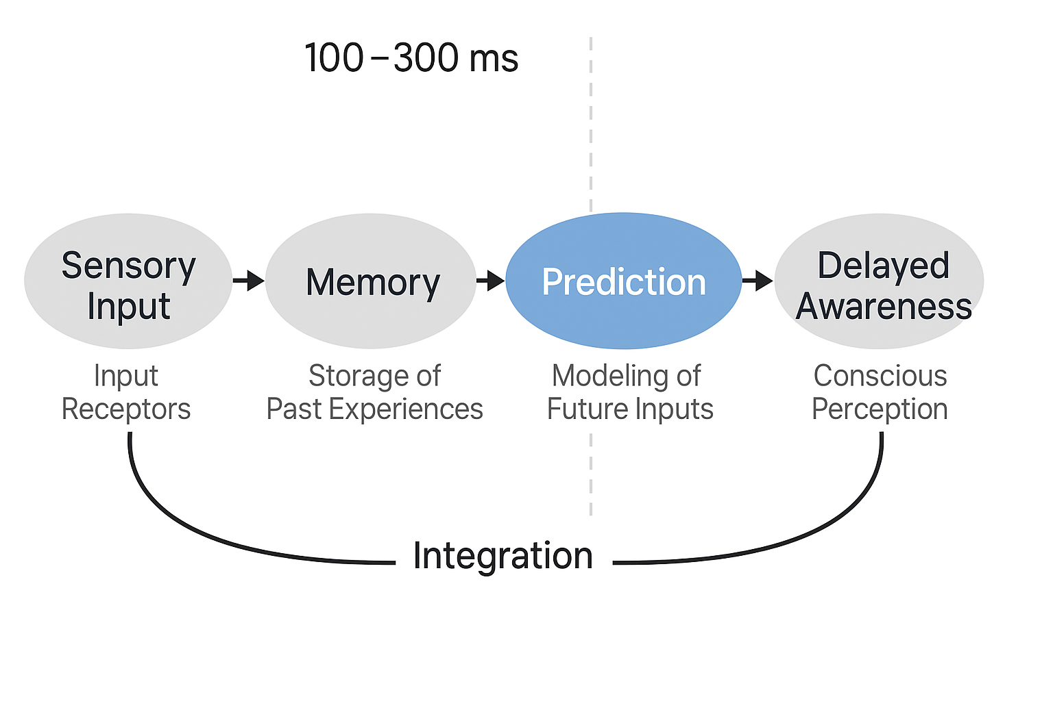

* A flowchart illustrating the path from physical stimulus through sensory processing, predictive integration, and recursive modeling to conscious realization, emphasizing delay and memory as core components.

**Figure 2: Universal Delayed Consciousness System Map**

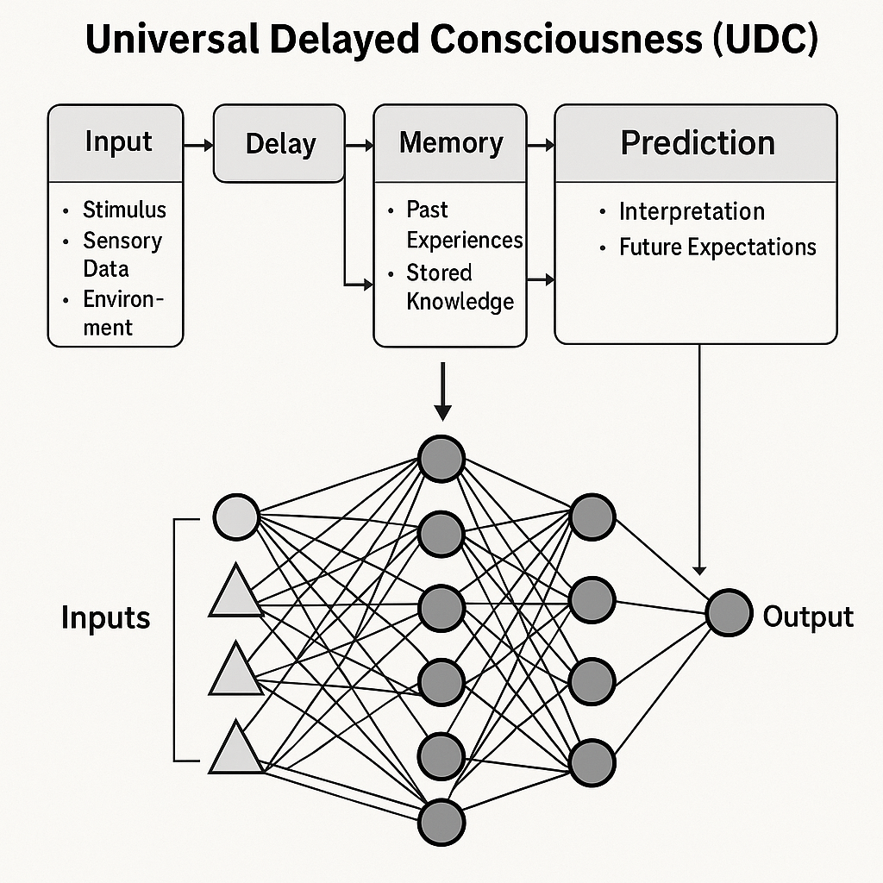

* A conceptual diagram outlining the UDC model's core processes: delayed sensory input, predictive modeling, memory integration, and recursive self-reference across substrates.

**Figure 3: Neuroanatomy and Functional Mapping**

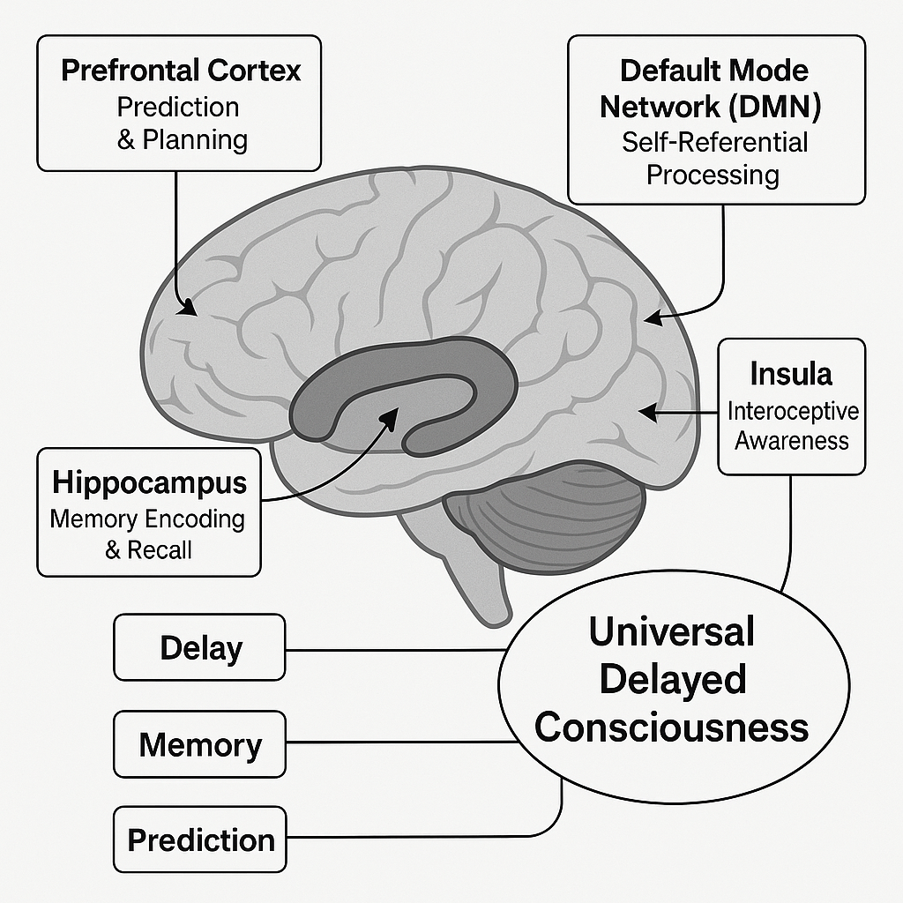

* A labeled diagram showing key brain regions (e.g., hippocampus, parietal lobe, insula) that support prediction, memory, and spatial awareness, in alignment with UDC processes.

**Figure 4: Spatiotemporal Anchoring**

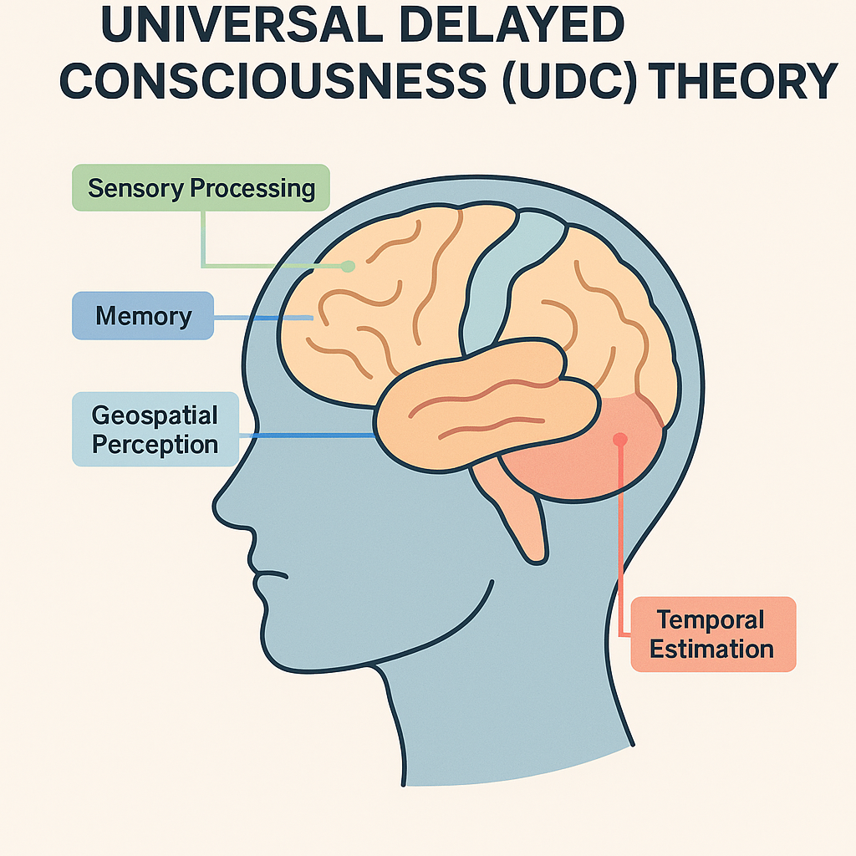

* An illustration of how the brain predicts and integrates time and location data using memory-driven mapping to create a coherent, present-aware perception.

**Figure 5: Unified Consciousness Architecture (Human, Animal, AI)**

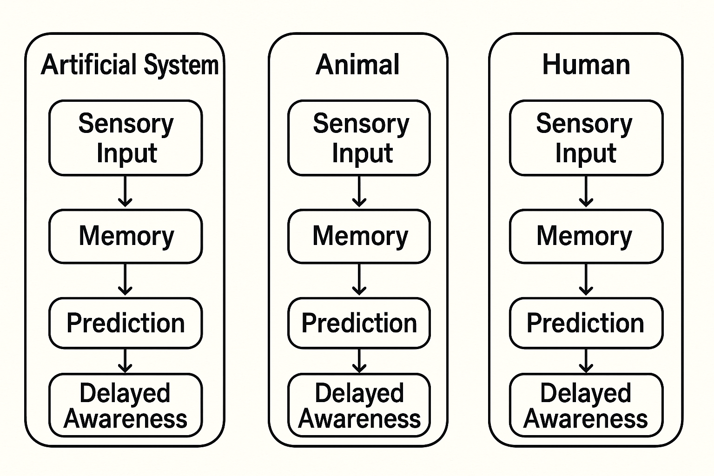

* A Venn-style diagram comparing how delayed input, memory, prediction, and integration manifest in humans, animals, and artificial systems — supporting UDC’s claim of substrate-agnostic sentience.

### 

### 

### 

### 

### 

### 

### 

### **Supporting Literature & Scientific Documentation**

The following sources offer scientific support for the foundational claims of UDC and are organized by their relevance to specific principles of the theory:

**Temporal Delay and Awareness**

* Libet, B., et al. (1983). Time of conscious intention to act in relation to onset of cerebral activity (readiness-potential). *Brain*. Demonstrates the measurable delay between neural activity and conscious intention.

**Predictive Modeling and Forecasting**

* Friston, K. (2010). The free-energy principle: a unified brain theory? *Nature Reviews Neuroscience*. Introduces a predictive coding framework aligned with UDC’s core premise.
* Seth, A. K. (2015). The cybernetic Bayesian brain: from interoceptive inference to sensorimotor contingencies. *Open MIND*. Supports UDC’s use of memory-based prediction in forming perception.

**Global Integration and Unified Experience**

* Dehaene, S., & Naccache, L. (2001). Towards a cognitive neuroscience of consciousness: basic evidence and a workspace framework. *Cognition*. Explains how consciousness emerges from system-wide integration.
* Tononi, G. (2008). Consciousness as integrated information: a provisional manifesto. *Biological Bulletin*. Supports UDC’s integrative model of awareness.

**Trauma, Memory, and Predictive Disruption**

* van der Kolk, B. (2014). *The Body Keeps the Score*. Describes how trauma affects memory and prediction systems in ways predicted by UDC.
* Koob, G. F., & Volkow, N. D. (2010). Neurocircuitry of addiction. *Neuropsychopharmacology*. Illustrates maladaptive prediction loops.
* Fletcher, P. C., & Frith, C. D. (2009). Perceiving is believing: a Bayesian approach to explaining the positive symptoms of schizophrenia. *Nature Reviews Neuroscience*. Provides evidence for overactive prediction errors.
* Goldstein, R. Z., & Volkow, N. D. (2011). Dysfunction of the prefrontal cortex in addiction. *Nature Reviews Neuroscience*. Reinforces predictive control and conscious choice modeling.

**Time and Spatial Estimation**

* Buhusi, C. V., & Meck, W. H. (2005). What makes us tick? Functional and neural mechanisms of interval timing. *Nature Reviews Neuroscience*. Explains how the brain represents and predicts time.
* Gauthier, J. L., & Tank, D. W. (2018). A dedicated population for segmenting time in the hippocampus. *Cell*. Shows evidence for time-tagging in memory structures.
* Epstein, R. A., & Vass, L. K. (2014). Neural systems for landmark-based spatial navigation: implications for the cognitive map. *Nature Reviews Neuroscience*. Supports the spatial grounding described in UDC.
* Wiener, M., et al. (2010). The image of time: a voxel-wise meta-analysis. *NeuroImage*. Confirms spatial and duration encoding in the brain.

Each of these sources provides evidence for one or more UDC components and collectively demonstrates its multidisciplinary scientific basis.